Grant County Anthrax Resources
Preventative actions you can take:
- Consider fly control measures, as biting flies have potential to spread it. Consider different modes of action for fly control - https://beef.unl.edu/beefwatch/2023/horn-flies-and-control-options
  - It is primarily spread from the environment to each animal via consumption, infected blood, or inhalation of spores in dirt/dust.– see attached publication: https://www.ag.ndsu.edu/publications/livestock/anthrax
  - Anthrax lives indefinitely in the subsoil, it is brought to the surface in abnormal wet or drought years.
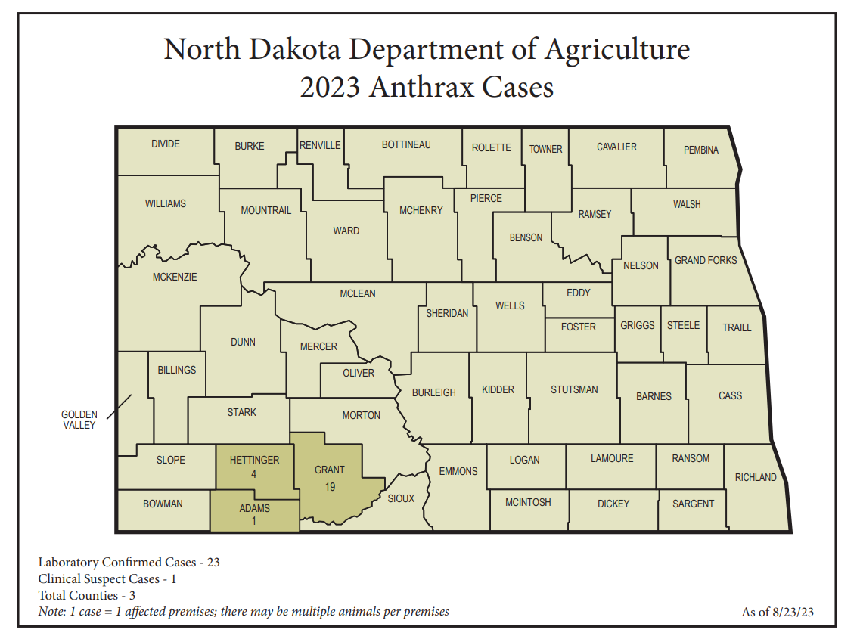
- Contact your veterinarian to discuss control measures and vaccinating the rest of your herd. Vaccine is relatively cheap, approximately $1/dose, immunity from the vaccine lasts approximately 6 months, so revaccination is required.
If you have had animal losses:
- Suspect Cases should first contact their veterinarian and the North Dakota Department – Division of Animal Health to obtain and submit a blood sample (Do NOT perform a necropsy or cut the deceased animal open-this can spread the spores).
  - Unusual illness or death in wildlife should be reported to ND Game and Fish. They have an online reporting tool: Wildlife Mortality Report | North Dakota Game and Fish
- After a sample comes back confirming the spores as anthrax, the producer or NDDA – Division of Animal Health will notify any fence-line contact.
- File notice for LIP(Livestock Indemnity Program) with FSA within 30 days (sooner the better)
  - Take dated pictures before carcasses are buried or burned.
- Organize carcass disposal – Utilize measures outlined in the attached Extension publication. Refer to steps listed below.
  - If a producer is unable to properly bury an infected carcass, please contact one of the following for help:
- **County Road & Bridge – Jon Alt 701-425-9251
- Mark Steinmetz 701-425-5498
- Art Weekes 701-370-9428
- Lee Cook (Liberty Dirtwork) 701-891-8212
Anthrax Disposal Crew Action Steps
- Review North Dakota Century Code 36-14-19. It has specific instructions on carcass disposal, and requires carcasses to be disposed of within 36 hours. Century Code | North Dakota Legislative Branch (ndlegis.gov)
- Risk of Anthrax transmission to individuals assisting with Anthrax Disposal is low. Protective measures to consider may include the following:
  - Cover cuts or abrasions
  - Do not eat, drink, or smoke during disposal/remediation activities
  - Wear personal protective equipment (PPE). At a minimum, wear disposable rubber gloves, long sleeves and pants, and rubber boots
  - If splashes or aerosolization is a possibility, consider wearing a mask and eye protection
  - Shower and separately launder clothing after disposal activities
  - For more information contact the Department of Health and Human Services at 701-328-2378.
- Refer to disposal methods outlined in attached publication: https://www.ag.ndsu.edu/publications/livestock/anthrax
  - Burning and burying the carcass where located is the preferred method to minimize spread. If unable to burn, bury at least 6ft deep, where located.
  - Consider and avoid any water ways or shallow water sources underground. Contact the State Water Department at (701) 328-2750 for confirmation.
  - Consider any underground electrical, gas, or water lines. Call 8-1-1 before you dig.
  - You can cover your loader bucket, etc. in plastic before lifting and moving any animal carcasses.
- Sanitize any equipment used, can torch blood on your equipment if it does not easily wash off with water and a detergent.
  - For more information on cleaning and disinfecting equipment to limit pathogens spread: https://www.ag.ndsu.edu/publications/livestock/biosecure-nutrient-management-practices
_ _ _ _ _ _ _ _ _ _ _ _ _ _ _ _ _ _ _ _ _ _ _ _ _ _ _ _ _ _ _ _ _ _ _ _ _ _ _ _ _ _ _ _ _ _ _ _ _ _ _ _ _ _ _ _
Materials for use in Cremation:
- Old tires, railroad ties, treated wood, asphalt shingles and used oil may NOT be used. Straw, coal, old hay, flax hay, dried leaves, dry wood chips, pallets, branches, dead/dry trees, and old buildings are all examples of acceptable combustibles.
  - If you have questions regarding what types of materials are acceptable to use in the burn, contact the North Dakota Department of Environmental Quality, Division of Air Quality, at 701-328-5188.
- The approximate quantities of fuel that will be needed for a 1,000 pound carcass are 100 pounds of straw, 2½ gallons of accelerant (kerosene, diesel) and 2 tons of wood or ½ ton of wood and ½ ton of coal.
  - Center Coal Company, https://www.centercoal.com/, 701-794-3400 sells retail coal. If soil and other related materials cannot be incinerated, they can be disinfected with a 5% formaldehyde solution at 50 quarts per square yard.
Anthrax is not spread via manure. It is possible, though highly unlikely, that the lots haulers are spreading out of may contain anthrax spores in the soil and if they dig too deep there is potential of them spreading spores when applying manure. Again, very low probability.
If heavy equipment operators who want to help with disposal are concerned about how to safely clean their equipment before leaving the site, NDSU Veterinary Diagnostic Lab confirmed the following:
- Remove ALL dirt, blood, hair and other materials with hot water and detergent.
  - The soil that is of greatest concern is what lies directly under the carcasses of animals which have died of anthrax, where blood and other fluid from the carcasses has leaked. That soil likely contains a high concentration of anthrax organisms, which is why that soil should be buried with the carcass.
- Divert the wash water from the equipment into the pit for incineration.
- A freshly prepared 10% bleach solution is always a good bet, but it is imperative that the equipment be thoroughly rinsed to remove organic matter (blood, hair, etc.) before application of bleach.
  - Longer is better - 10 minutes should be the minimum for contact time, but to improve efficacy repeatedly drenching with bleach and allowing to sit in the sun an hour or more would add to the efficacy.
For further information or if you have questions, please contact Grant County Emergency Services at 701-622-3944 or Grant County Extension at 701-622-3470.

